Assignment (N+) Day-1(OSI)
Task-1:
TCP
DNS
TLS
QUIC

Task-2:
TCP (Transmission Control Protocol): Layer 4 (Transport Layer)
DNS (Domain Name System): Layer 7 (Application Layer)
TLS (Transport Layer Security): Ise officially Layer 6 (Presentation Layer)
QUIC (Quick UDP Internet Connections): Ye primarily Layer 4 (Transport Layer)

Task-3:
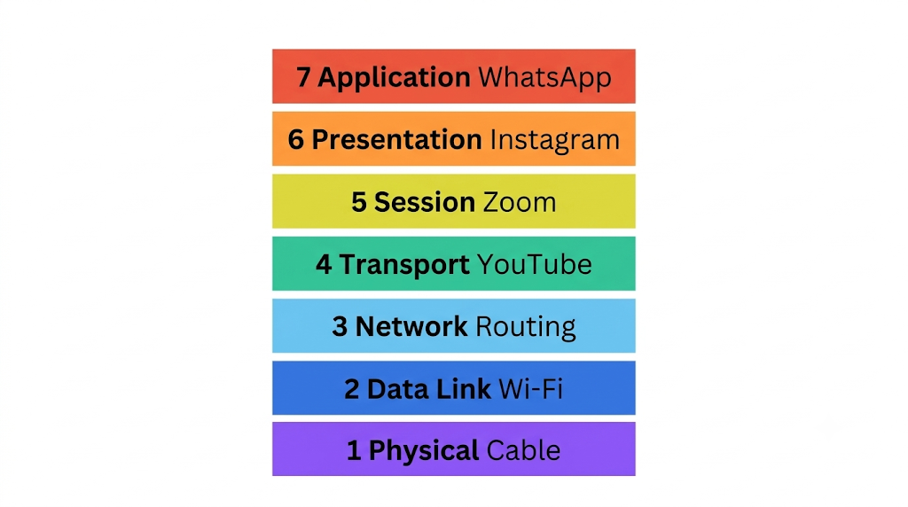
- Layer 7 - Application: WhatsApp (The user interface where you type and send messages).
- Layer 6 - Presentation: Instagram (Compressing, encrypting, and formatting your JPEG photos so they load securely).
- Layer 5 - Session: Zoom (Opening, maintaining, and closing the active video call session between you and the server).
- Layer 4 - Transport: YouTube (Breaking down the video into packets and using TCP/UDP to ensure smooth streaming without crashes).
- Layer 3 - Network: Google Maps / Routing (IP addressing and finding the fastest logical path across the internet to load map tiles).
- Layer 2 - Data Link: Wi-Fi (Handling MAC addresses and transferring data frames across your local home network).
- Layer 1 - Physical: Ethernet Cable / Radio Waves (The actual physical cables or Wi-Fi radio frequencies pushing the raw 1s and 0s).

Task-4:
1. Application Layer (Layer 7): The Interface You open WhatsApp and type "Hello!". This layer is the app itself interacting with you. It takes your text and prepares it to be sent.
2. Transport Layer (Layer 4): The Packager Your phone breaks that "Hello!" into smaller data pieces called segments. It numbers them so that if they get mixed up during travel, your friend's phone knows how to put them back together in the exact right order.
3. Network Layer (Layer 3): The GPS / Post Office This layer adds the "To" and "From" IP addresses to your data pieces. Just like writing a home address on an envelope, it helps the internet routers find the best and fastest path to your friend's phone.
4. Physical Layer (Layer 1): The Actual Journey Finally, your phone converts all that addressed data into raw digital signals (1s and 0s). It shoots them out of your phone's antenna as Wi-Fi radio waves to your home router, starting their physical journey across the internet.

